1. Write a SQL statement to insert a record as follows:

Employees :

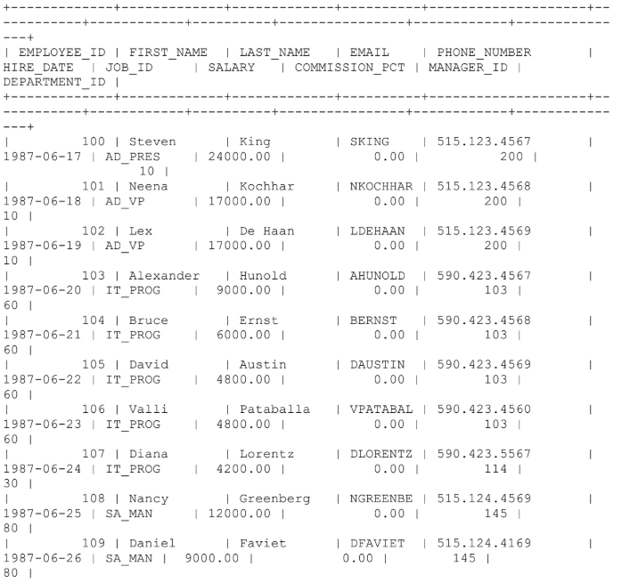

Department :

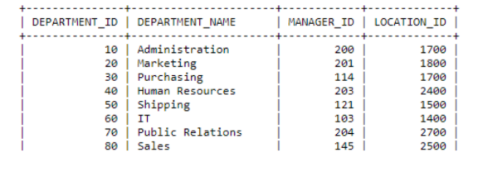

mysql> create table employee1;

ERROR 4028 (HY000): A table must have at least one visible column.

mysql>

mysql>

mysql> create table employee1

-> (employee_id int,

-> first_name varchar(30),

-> last_name varchar(30),

-> email varchar(30),

-> phone_no varchar(30),

-> hire_date date,

-> job_id varchar(30),

-> salary decimal(7,2),

-> commission_pct decimal(7,2),

-> manager_id int,

-> department_id int);

Query OK, 0 rows affected (0.02 sec)

mysql> insert into employee1 values(100,'steven','king','sking','515.123.4567','1987-06-17','ad-pres',24000,0,200,10);

Query OK, 1 row affected (0.01 sec)

mysql> insert into employee1 values(101,'neena','kochhar','nkochhar','515.123.4568','1987-06-18','ad-vp',17000,0,200,10);

Query OK, 1 row affected (0.01 sec)

mysql> insert into employee1 values(102,'lex','de haan','ldehaan','515.123.4569','1987-06-19','ad-vp',17000,0,200,10);

Query OK, 1 row affected (0.00 sec)

mysql> insert into employee1 values(103,'alexander','hunold','ahunold','590.423.4567','1987-06-20','it_prog',9000,0,103,60);

Query OK, 1 row affected (0.01 sec)

mysql> insert into employee1 values(104,'bruce','ernest','bernest','590.423.4568','1987-06-21','it_prog',6000,0,103,60);

Query OK, 1 row affected (0.00 sec)

mysql> insert into employee1 values(105,'david','austin','daustin','590.423.4569','1987-06-22','it_prog',48000,0,103,60);

Query OK, 1 row affected (0.01 sec)

mysql> insert into employee1 values(106,'valli','pataballa','vpatabal','590.423.4560','1987-06-23','it_prog',4800,0,103,60);

Query OK, 1 row affected (0.00 sec)

mysql> insert into employee1 values(107,'diana','lorentz','dlorentz','590.423.5567','1987-06-24','it_prog',4200,0,114,60);

Query OK, 1 row affected (0.00 sec)

mysql> insert into employee1 values(108,'nancy','greenberg','ngreenbe','515.124.4569','1987-06-25','sa_man',12000,0,145,80);

Query OK, 1 row affected (0.00 sec)

mysql> insert into employee1 values(109,'daniel','faviet','dfaviet','515.124.4169','1987-06-26','sa_man',9000,0,145,80);

Query OK, 1 row affected (0.01 sec)

mysql> table employee1;

+-------------+------------+-----------+----------+--------------+------------+---------+----------+----------------+------------+---------------+

| employee_id | first_name | last_name | email | phone_no | hire_date | job_id | salary | commission_pct | manager_id | department_id |

+-------------+------------+-----------+----------+--------------+------------+---------+----------+----------------+------------+---------------+

| 100 | steven | king | sking | 515.123.4567 | 1987-06-17 | ad-pres | 24000.00 | 0.00 | 200 | 10 |

| 101 | neena | kochhar | nkochhar | 515.123.4568 | 1987-06-18 | ad-vp | 17000.00 | 0.00 | 200 | 10 |

| 102 | lex | de haan | ldehaan | 515.123.4569 | 1987-06-19 | ad-vp | 17000.00 | 0.00 | 200 | 10 |

| 103 | alexander | hunold | ahunold | 590.423.4567 | 1987-06-20 | it_prog | 9000.00 | 0.00 | 103 | 60 |

| 104 | bruce | ernest | bernest | 590.423.4568 | 1987-06-21 | it_prog | 6000.00 | 0.00 | 103 | 60 |

| 105 | david | austin | daustin | 590.423.4569 | 1987-06-22 | it_prog | 48000.00 | 0.00 | 103 | 60 |

| 106 | valli | pataballa | vpatabal | 590.423.4560 | 1987-06-23 | it_prog | 4800.00 | 0.00 | 103 | 60 |

| 107 | diana | lorentz | dlorentz | 590.423.5567 | 1987-06-24 | it_prog | 4200.00 | 0.00 | 114 | 60 |

| 108 | nancy | greenberg | ngreenbe | 515.124.4569 | 1987-06-25 | sa_man | 12000.00 | 0.00 | 145 | 80 |

| 109 | daniel | faviet | dfaviet | 515.124.4169 | 1987-06-26 | sa_man | 9000.00 | 0.00 | 145 | 80 |

+-------------+------------+-----------+----------+--------------+------------+---------+----------+----------------+------------+---------------+

10 rows in set (0.00 sec)

2. Write a SQL statement to insert 3 rows by a single insert statement.

mysql> INSERT into department

-> (department_id,department_name,manager_id,location_id)

-> VALUES

-> (10,'administration',200,1700),

-> (20,'marketing',201,1800),

-> (30,'purchasing',114,1700),

-> (40,'humanresources',203,2400);

Query OK, 4 rows affected (0.01 sec)

Records: 4 Duplicates: 0 Warnings: 0

mysql> INSERT into department

-> (department_id,department_name,manager_id,location_id)

-> VALUES

-> (50,'shipping',121,1500),

-> (60,'IT',103,1400),

-> (70,'public relations',204,2700),

-> (80,'sales',145,2500);

Query OK, 4 rows affected (0.00 sec)

3. Write a SQL statement to insert one row in jobs table to ensure that no duplicate

value will be entered in the job_id column.

mysql> create table jobs

-> (job_id varchar(20) unique,

-> job_title varchar(30),

-> min_salary decimal(7,2),

-> max_salary decimal(7,2));

Query OK, 0 rows affected (0.04 sec)

mysql> insert into jobs

-> (job_id,job_title,min_salary,max_salary)

-> values

-> ('ad_pres','president',20000,40000),

-> ('ad_vp','administration vice president',15000,30000),

-> ('ad_asst','administration assistant',3000,6000),

-> ('fi_mgr','finance manager',8200,16000),

-> ('fi_account','accountant',4200,9000),

-> ('ac_mgr','accounting manager',8200,16000),

-> ('ac_account','public accountant',4200,9000),

-> ('sa_man','sales manager',10000,20000);

Query OK, 8 rows affected (0.01 sec)

Records: 8 Duplicates: 0 Warnings: 0

mysql> table jobs;

+------------+-------------------------------+------------+------------+

| job_id | job_title | min_salary | max_salary |

+------------+-------------------------------+------------+------------+

| ad_pres | president | 20000.00 | 40000.00 |

| ad_vp | administration vice president | 15000.00 | 30000.00 |

| ad_asst | administration assistant | 3000.00 | 6000.00 |

| fi_mgr | finance manager | 8200.00 | 16000.00 |

| fi_account | accountant | 4200.00 | 9000.00 |

| ac_mgr | accounting manager | 8200.00 | 16000.00 |

| ac_account | public accountant | 4200.00 | 9000.00 |

| sa_man | sales manager | 10000.00 | 20000.00 |

+------------+-------------------------------+------------+------------+

8 rows in set (0.00 sec)

4. Write SQL statement to increment salary of each emp by 10%.

mysql> UPDATE jobs

-> SET min_salary = (min_salary*0.1)+min_salary

-> AND max_salary = (max_salary*0.1)+max_salary;

Query OK, 8 rows affected (0.03 sec)

Rows matched: 8 Changed: 8 Warnings: 0

mysql> table jobs;

+------------+-------------------------------+------------+------------+

| job_id | job_title | min_salary | max_salary |

+------------+-------------------------------+------------+------------+

| ad_pres | president | 0.00 | 40000.00 |

| ad_vp | administration vice president | 0.00 | 30000.00 |

| ad_asst | administration assistant | 0.00 | 6000.00 |

| fi_mgr | finance manager | 0.00 | 16000.00 |

| fi_account | accountant | 0.00 | 9000.00 |

| ac_mgr | accounting manager | 0.00 | 16000.00 |

| ac_account | public accountant | 0.00 | 9000.00 |

| sa_man | sales manager | 0.00 | 20000.00 |

+------------+-------------------------------+------------+------------+

8 rows in set (0.00 sec)

5. Write a SQL statement to change the email column of employees table with 'not

available' for those employees whose department_id is 80 and gets a

commission is less than .20%

mysql> UPDATE employee1

-> set email = 'not available'

-> where department_id = 80 AND commission_pct <0.20;

Query OK, 2 rows affected (0.02 sec)

Rows matched: 2 Changed: 2 Warnings: 0

6. Write a SQL statement to change the email column of employees table with 'not

available' for those employees who belongs to the 'Purchasing' department.

mysql> UPDATE employee1

-> SET email = 'not available'

-> where department_id = (select department_id from department where

-> department_name ='purchasing');

Query OK, 0 rows affected (0.03 sec)

Rows matched: 0 Changed: 0 Warnings: 0

7. Write a SQL statement to change the email and commission_pct column of

employees table with 'not available' and 0.10 for all employees.

mysql> UPDATE employee1

-> SET email = 'not available', commission_pct = 0.10;